
Lab Number: 13 Date: 2025/08/27
Title: FTP Configuration and Implementation using Packet
Tracer
Theory:
- FTP (File Transfer Protocol): FTP is a standard network protocol used to transfer files between a client and a server over a TCP/IP network. It uses port 21 for control commands and port 20 for data transfer in active mode. Clients can access servers either anonymously or with authentication. FTP operates in two modes: active and passive, depending on whether the server or client initiates the data connection. For secure transfers, FTPs or SFTP can be used to encrypt data. FTP supports various file operations such as uploading, downloading, and managing files and directories operations such as uploading, downloading, and managing files and directories through specific commands like RETR, STOR, and DELE. In ASCII mode, it handles text files by converting line endings between different operating systems, while in binary mode, it preserves the exact byte sequence of files. Despite its functionality, FTP is considered less secure compared to modern protocols due to its lack of built-in encryption, making secure alternatives like FTPs and SFTP preferable for sensitive data transfers.

- Key Concepts of FTP
- Client-Server Model: FTP follows a client-server architecture where the client initiates request for file operations and the server responds. The client communicates with the server to request files, upload files, or perform other file management tasks.
- Ports: FTP uses port 21 for the control connection, where commands and responses are exchanged. Port 20 is used for the data connection in activate mode, while passive mode uses a dynamically assigned port by the server for data transfer.
- Active and Passive Modes: In active mode, the client opens a port for data transfer and the server connects to it. In passive mode, the server opens a port for and the client connects to it, which helps navigate firewalls and NAT issues.
- Authentication: FTP can operate in anonymous mode, allowing users to access files without a password, or in authenticated mode, requiring a username and password for access. This distinction helps manage access and security.
- FTP Commands: Common FTP commands include LIST to view files, RETR to download files, STOR to upload files, DELE to delete, and MKD to create directories.
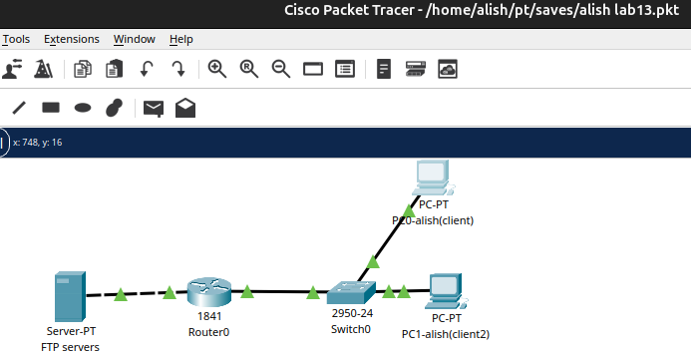
- Network Diagram

Fig: Network diagram

Implementation Sequence
- Configuring FTP Server and FTP Client
FTP Server Configuration
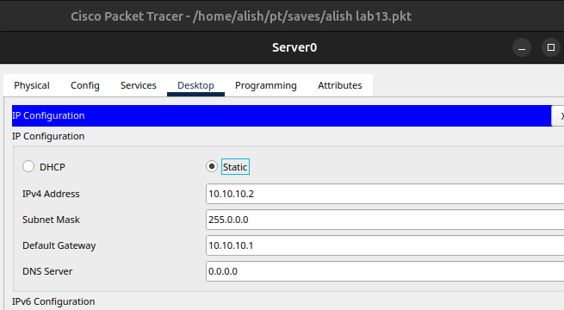
Step 1: Click on server and go to IP configuration and set IP address and subnet mask.

Fig: IP configuration on Server

Step 2: Click on server go to service, click ftp and click on ON button.
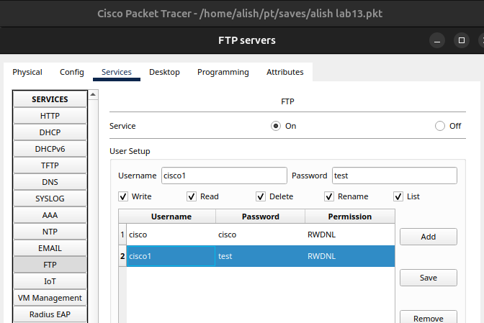
Step 3: Set username, password, and tick write, read, delete, rename, and list. Click add.

Fig: Server Configuration
Step 4: Go to PC, click text editor write something and save the file as hello.txt
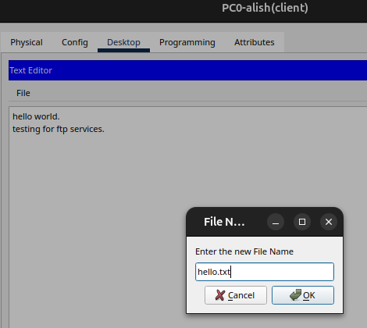

Fig: Creating a file name hello.txt
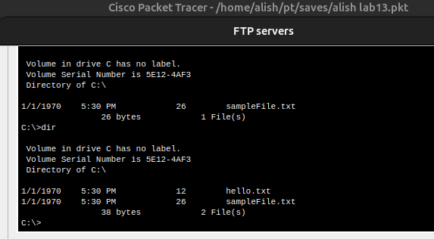
Step 5: In desktop, open command prompt and type dir command, we can see the file.

Fig: Using dir command to see file
- FTP Server Configuration
In command prompt type command ‘ftp 10.10.10.2’ then insert username and password,
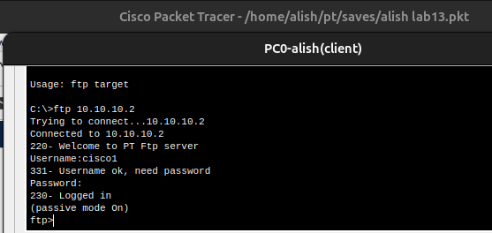
We will be connected to ftp server.

Fig: FTP Server Connection
- FTP Client Configuration
Step 1: Click on pc and go to IP configuration and set IP address and subnet mask.
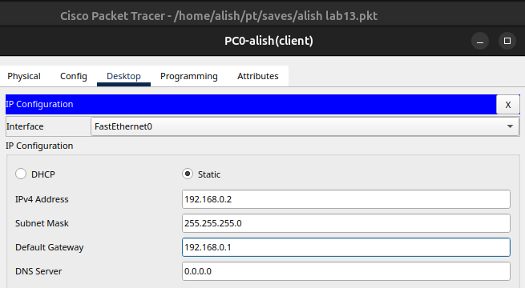

Fig: IP Configuration in Clients
- Implementation
Transferring File Using PUT Command
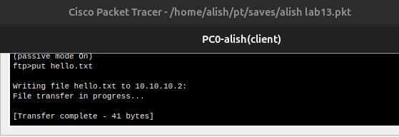
Command: Ftp> put hello.txt

Fig: Transferring file using PUT command

RENAME File
Command: Ftp>rename hello.txt test.txt
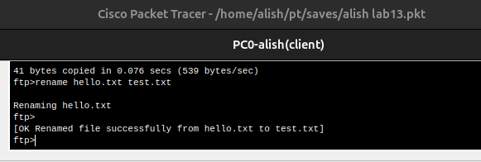

Fig: Renaming file

Get The File and Save The Copy on Our Machine
Command: Ftp> get hello.txt
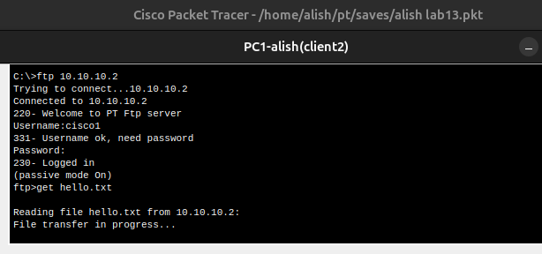

fig: Downloading file hello.txt in another client PC
Go To PC
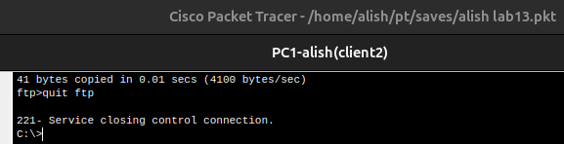
Command: Ftp> quit ftp

Fig: Quitting FTP
Displaying The Files
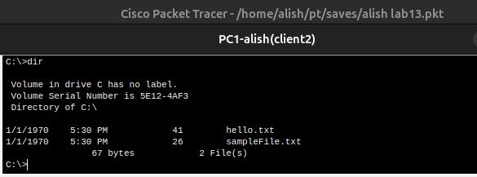
Command: PC> dir

Fig: Displaying the file ‘hello.txt’ downloaded in Client-2

Addressing Table:
The addressing table of this lab is as follows:
Device | Interface | IPv4 Address | Subnet
Alish(client1) | NIC | 192.168.0.2 | 255.255.255.0
Alish(Client 2) | NIC | 192.168.0.3 | 255.255.255.0
Server(ftp) | NIC | 10.10.10.2 | 255.0.0.0

Conclusion
In this lab, we successfully configured an FTP server and client using Packet Tracer. By following the step-by-step process, we understood how to set up an IP address,create user accounts with appropriate permissions, and demonstrated file management using FTP commands. This practical implementation helps in understanding of FTP’s client-server model, the role of IP addressing, and the importance of secure file transfer operations in network environments.

